**Approach and Main Results for RQ1: Vessel Cost Structure in Relation to Vessel Size**

This section discusses the impact of vessel size on vessel cost structure. Simulations were conducted using the Antwerp Port Model Program to calculate vessel costs of different vessel sizes. A 23,964 TEU vessel was selected as the baseline, alongside six smaller vessels, including one LNG vessel.

The initial cost analysis is based on a single loop voyage, starting from Ningbo Port, traveling west to deliver goods to Western Europe, and eventually returning to China. The total cost per loop is calculated by summing the total variable cost (including running costs, voyage costs, and port charges), port handling costs, and fixed costs. Figures 1 and 2 illustrate the total cost per loop and the cost structure. Apart from the 14,800 TEU LNG vessel, total loop costs exhibit an almost linear increase with vessel size. The cost components follow a similar trend. Not like other vessels, the LNG vessel has higher costs due to a substantial rise in voyage costs, which will be discussed in the next section. Other cost components follow a growth pattern similar to the 14,990 TEU vessel, which has a comparable weight.

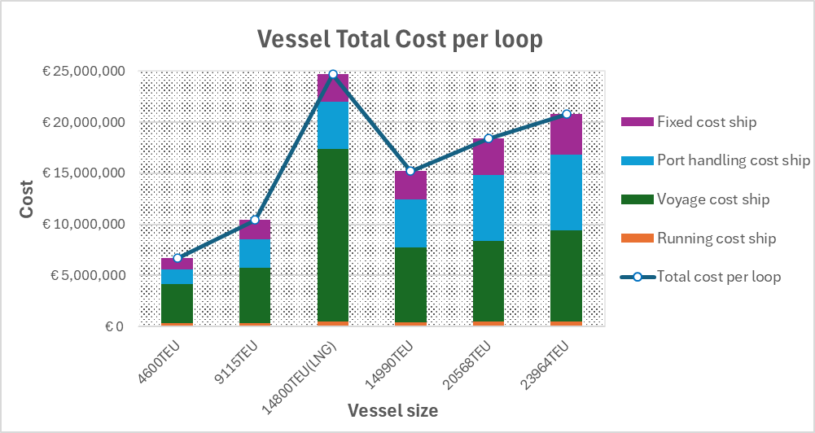 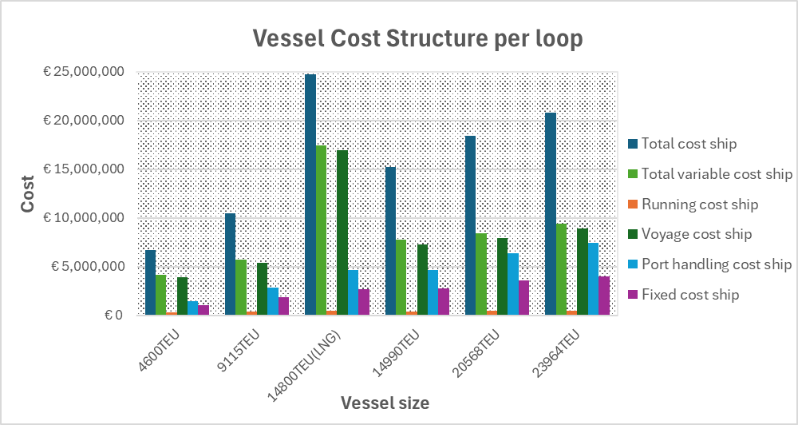

Figure 1 Figure 2

Since variations in vessel size affect cruising speed, port time, and other operational factors, the number of loops completed per year varies across vessel sizes. Therefore, the annual total cost and cost structure were also analyzed. As shown in Figures 3 and 4, the annual cost follows a similar pattern to the per-loop cost. With increasing vessel size, the proportion of voyage costs in the total cost slightly decreases, offset by a minor increase in port handling costs.

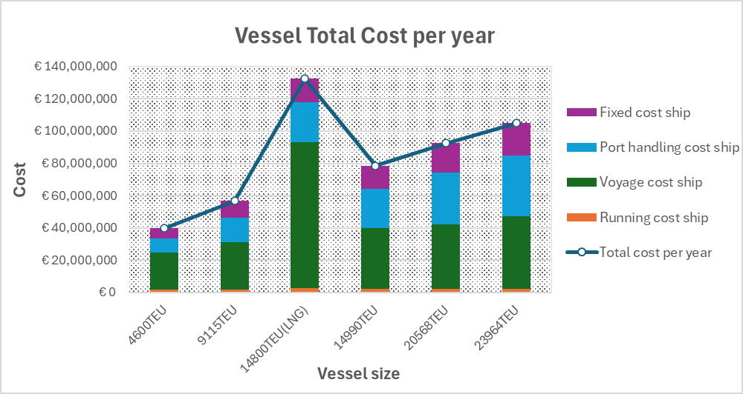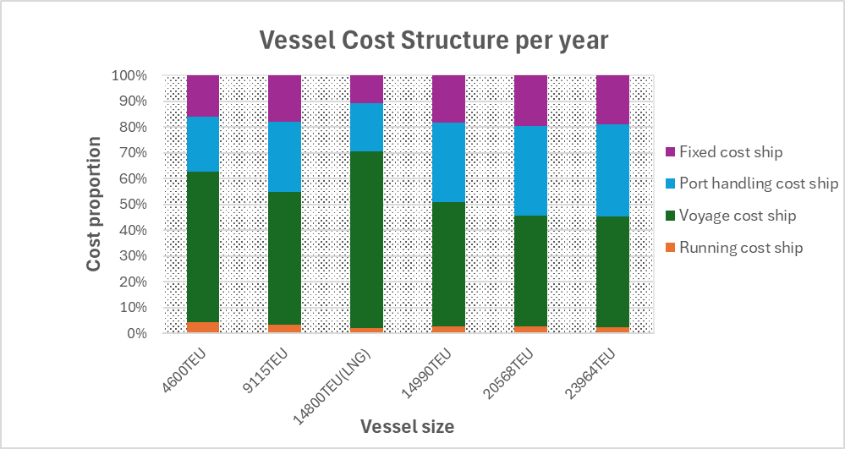

Figure 3 Figure 4

Figure 5 illustrates the total cost per TEU. Excluding the LNG vessel, the cost per TEU decreases as vessel size increases, with the rate of decline slowing as size grows. This reduction is primarily driven by a sharp drop in voyage cost per TEU, along with slight decreases in running and fixed costs. In contrast, port handling costs remain stable.

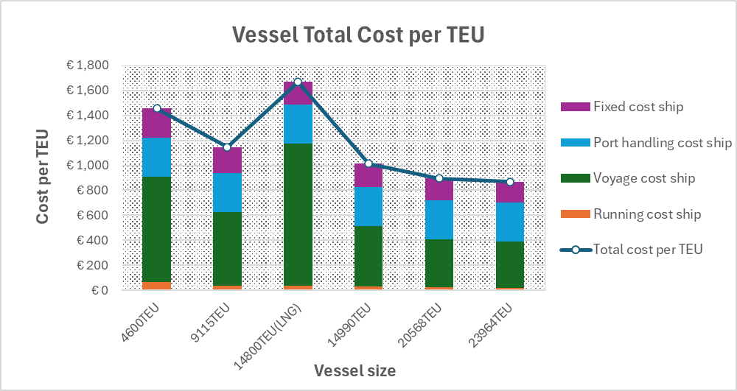

Figure 5

Beyond total cost variations, running and voyage costs were examined to identify cost patterns. Running costs consist of management, repair and maintenance, insurance, stores, and manning costs. As shown in Figure 6, insurance and manning costs account for the largest share of running costs. Insurance costs increase steadily with vessel size, while crew and management costs decrease. Voyage costs include fuel costs (in port, ECA, and non-ECA zones), lubricant oil costs, external costs, ETS costs, and cannel costs. Figure 7 highlights that cannel costs and non-ECA fuel costs are the most prominent contributors. As vessel size increases, cannel costs rise while non-ECA fuel costs decline. Additionally, the exceptionally high non-ECA fuel cost is the primary driver of the LNG vessel’s elevated voyage cost.

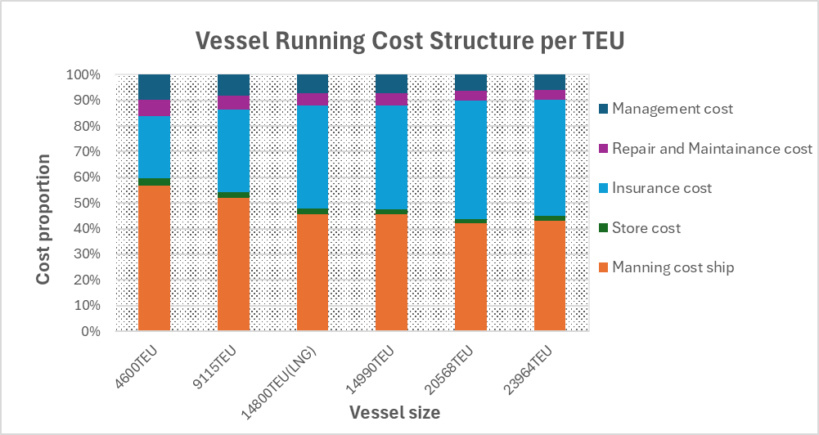 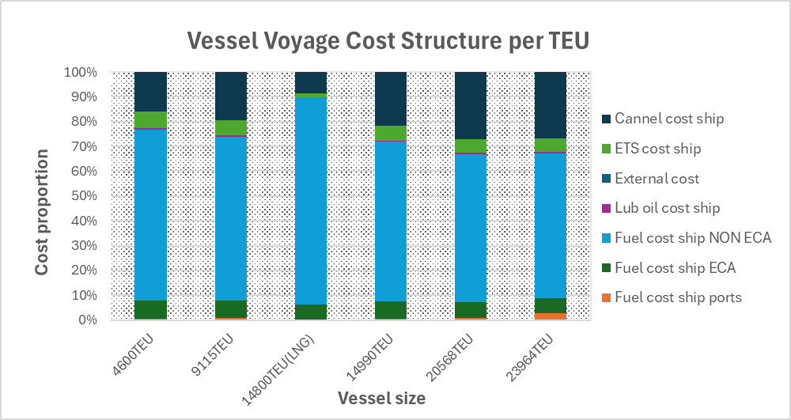

Figure 6 Figure 7